**The Coming Weeks at a Glance**

June 8th TUES 6:00PM Festival Meeting

June 9th WED 7:00PM Ministry Gathering

**Worship Helpers**

Acolyte Ellie

Acolyte next week Audrey

Greeters today No Greeters

Greeters next week No Greeters

Nursery today No Nursery

Nursery next week No Nursery

Scripture Reader Erma

Scripture Reader next week Carol

June Card Person Audrey

Counters Diana & Carol

Counters next week Volunteer & Ron

Ushers for June Norman, Craig, Rick

Ushers for July Tony, Ron, Steve

Head Usher Ron

Assistant Head Usher Craig

Sound Technician Steve

Organist Nancy

-----------------------------------------------------------------------------------

Attendance and Financial Information as of May 30, 2021

Worship: 48 Sunday school:

Envelopes and Plate: $1,620.00 Sunday school: $0.00

Brett’s Scouting Project: $6.00 Flowers: $6.00

Missions: $25.00 Food Bank: $100.00

Amounts include electronic giving through May 30, 2021

Total Budgeted Amount: $73,722 Received to Date: $57,846

(Total budgeted amount: 42.31% Received amount: 33.20%)

Shares of Ministry are paid through January 2021

Balls Mills United Methodist Church

5941 Bloomingrove Road, Cogan Station, PA 17728

Office 570-494-1614 Parsonage 570-494-0398 www.ballsmillsumc.org

Pastor Christopher Weems [cweems@susumc.org](mailto:cweems@susumc.org) Cell: 570-502-2954

Office Hours: Monday through Friday: 9 AM – 5 PM or By Appointment

1CCLI Song #7056333, 2CCLI Song #56204, 3CCLI Song #7129060, 4CCLI Song #114122

CCLI License #1894594

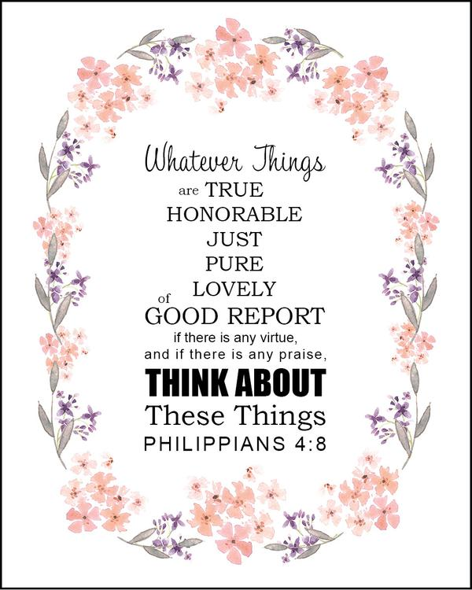

**Welcome!**

**Graduation Sunday**

**Balls Mills United Methodist Church**

**June 6, 2021**



**June 6, 2021**

**PRE-SERVICE PRAYER AT 8:30 AM**

**THE PRELUDE** “The Church in the Wildwood” By: Richard Mules

**WELCOME AND ANNOUNCEMENTS**

**SERVICE OF THE ACOLYTE:** Let the light of Christ come in.

**HYMN:** “Near to the Heart of God”1 #472 (on screen)

**SCRIPTURE READING:** Joshua 1:7-9 & Philippians 4:4-8

Erma

**GRADUATION SUNDAY**

Alyssa Chestnut Jackie Snyder

Marisa Nicole Schrock Sarah Ashley

Jacob Dgien Christopher Edward Weems

Rei Saar

**SPECIAL MUSIC** Bruce

**JOYS AND CONCERNS:** For these things, we hold in our hearts.

**PASTORAL PRAYER**

**THE LORD’S PRAYER**

**CHILDREN’S TIME**

**OFFERING AND OFFERTORY** “Jesus Shall Reign” By: Eric Lewis

**DOXOLOGY**

“Praise God, from Whom All Blessings Flow”2#95(on screen)

**OFFERTORY PRAYER**

**SCRIPTURE READING:** Genesis 37:5-10 Erma

**SERMON:** “You Can’t Have My Dream” Pastor Weems

**INVITATION OF DISCIPLESHIP**

**SACRAMENT OF HOLY COMMUNION**

**HYMN:** “See A Victory”3 (on screen)

By: Ben Fielding, Chris Brown, Jason Ingram, Steven Furtick

Produced By: Playback Media

**PASTORAL BENEDICTION**

**CHORAL BENEDICTION:** “Shalom to You”4 #666

**SERVICE OF THE ACOLYTE:** Take the light of Christ into the world



**ANNOUNCEMENTS**

**MESSAGE FROM PASTOR WEEMS:** Pastor Weems wants to know about what’s going on with you throughout the week. Please feel free to stay after the Sunday service and talk to him as much as you’d like!

**UPCOMING LAWN MOWING TEAMS:**

June 10th: Team 3 – Ed, Rich, Reuben

June 17th: Team 4 – Ken, Bob, Jon

**EAGLE SCOUT PROJECT:** Brett will be doing his Eagle Scout Project on the ground of the former community hall creating an outdoor worship and group activity area. The project consists of leveling a 40’ x 60’ area toward the back of the lot, covering it with weed block, stone mulch, and a fire pit in the center. The border will be partially landscaped with evergreen trees for privacy. Donations would be greatly appreciated to help with the cost of materials (stone, weed block, fire pit, and evergreen trees). If you need a donation envelope they are next to the bulletins.

**FESTIVAL MEETING:** A festival meeting will be held on Tuesday, June 8th at 6:00PM. Open to anyone who wishes to join!